
User Manual
Suction Vacuum Sealer
Model: V22
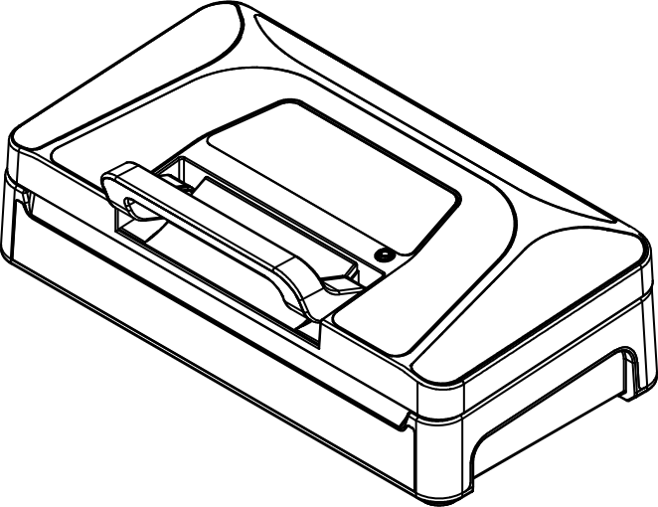

Precision Appliance Technology, Inc.
www.vestaprecision.com
Table of Contents
Important Safety Information 3
Product Usage Guidelines 5
Product Components 6
Features and Options 7
Operation Instructions 9
How to use the built-in cutter 9
How to use the Seal function 9
How to extend the seal time 10
How to use the Vacuum & Seal function 10
How to use the Pulse Vac function 11
How to use the hose 12
How to vacuum seal Mason Jars 12
How to vacuum Canisters 13
How to marinate 13
Maintenance 15
Troubleshooting 16
Cannot operate 16
Insufficient vacuum 16
Cannot seal or poor sealing performance 16
Bag loses vacuum after sealing 17
Error alarm 17
No vacuum in accessories mode 17
Liquid intrusion (Special circumstances) 18
Technical Specifications 20
Vacuum Packaging Basics 21
Vacuum food storage reference 23

Important Safety Information
Before using this machine, please read all instructions in this manual carefully and always follow the safety precautions below.

- This appliance is intended for household use only. Do not use it for any purpose other than its intended design.
- Do not allow children to play with the appliance or the power cord. Children, persons with reduced physical, sensory, or cognitive abilities should use this appliance under adult supervision. Always supervise children during use to prevent accidents.
- Small parts and vacuum bags may pose a choking hazard. Keep them out of reach of children.
- Do not use this appliance in environments containing flammable or explosive gases. Do not use it in high-temperature or high-humidity conditions that may compromise the safe operation of household appliances.
- Ensure that the power supply voltage matches the voltage indicated on the appliance rating label.
- Do not leave the appliance unattended while in operation.
- The cutter contains a sharp blade. Do not handle the underside to avoid injury.
- After sealing, the sealing area may become hot. Do not touch it to avoid burns.
- Always disconnect the power supply after use.
- When unplugging the appliance, hold the plug firmly. Do not pull on the power cord.
- Do not immerse the appliance or power cord in water or any other liquid.
- The power cord must be connected directly to a properly grounded power outlet that meets safety regulations.
- If the plug, power cord, or appliance is damaged, stop using it immediately and contact the manufacturer or an authorized service center. Do not attempt to repair it yourself.
- Do not allow the power cord to hang over the edge of a table or countertop, where it may be pulled by children or cause tripping hazards.
- This appliance does not require any lubricants. Do not clean it with organic solvents.
- Do not dispose of this product with household waste. Please recycle or dispose of it in accordance with applicable regulations on electronic waste in your local area.
- Please retain this user manual for future reference.

Product Usage Guidelines
- This machine is only compatible with textured/embossed bags.
- For items with sharp points or edges, wrap the corners with soft materials such as puncture-resistant sheets or paper towels to prevent puncturing the vacuum bag.
- Vacuum bags can be used for heating or microwave heating. A small vent hole must be cut in the corner of the bag beforehand.
- Vacuum bags used for storage can be reused. However, bags used for heating or microwaving should be used only once. Bags that have stored raw fish or oily foods are not recommended for reuse.
- When placing the bag mouth over the vacuum tray, ensure the opening lies flat across the seal bar and the open edge of the bag is inserted under the bag retention tabs. This ensures proper airflow during vacuuming.
- Leave at least 2 inches (5 cm) of space between the bag opening and the food to prevent liquids from overflowing and contaminating the seal during vacuuming.
- When vacuuming liquids, sauces, or foods containing liquids or sauces, avoid wetting the bag opening. It is recommended to dry the bag opening after filling to ensure proper sealing.
- Soft, high-moisture foods or foods that need to maintain their shape achieve the best results when frozen before vacuum sealing.
- Do not place heavy objects on the vacuum lid, as this may cause damage.
- When the appliance is not in use, do not lock the lid, as prolonged pressure may deform the sealing gasket.

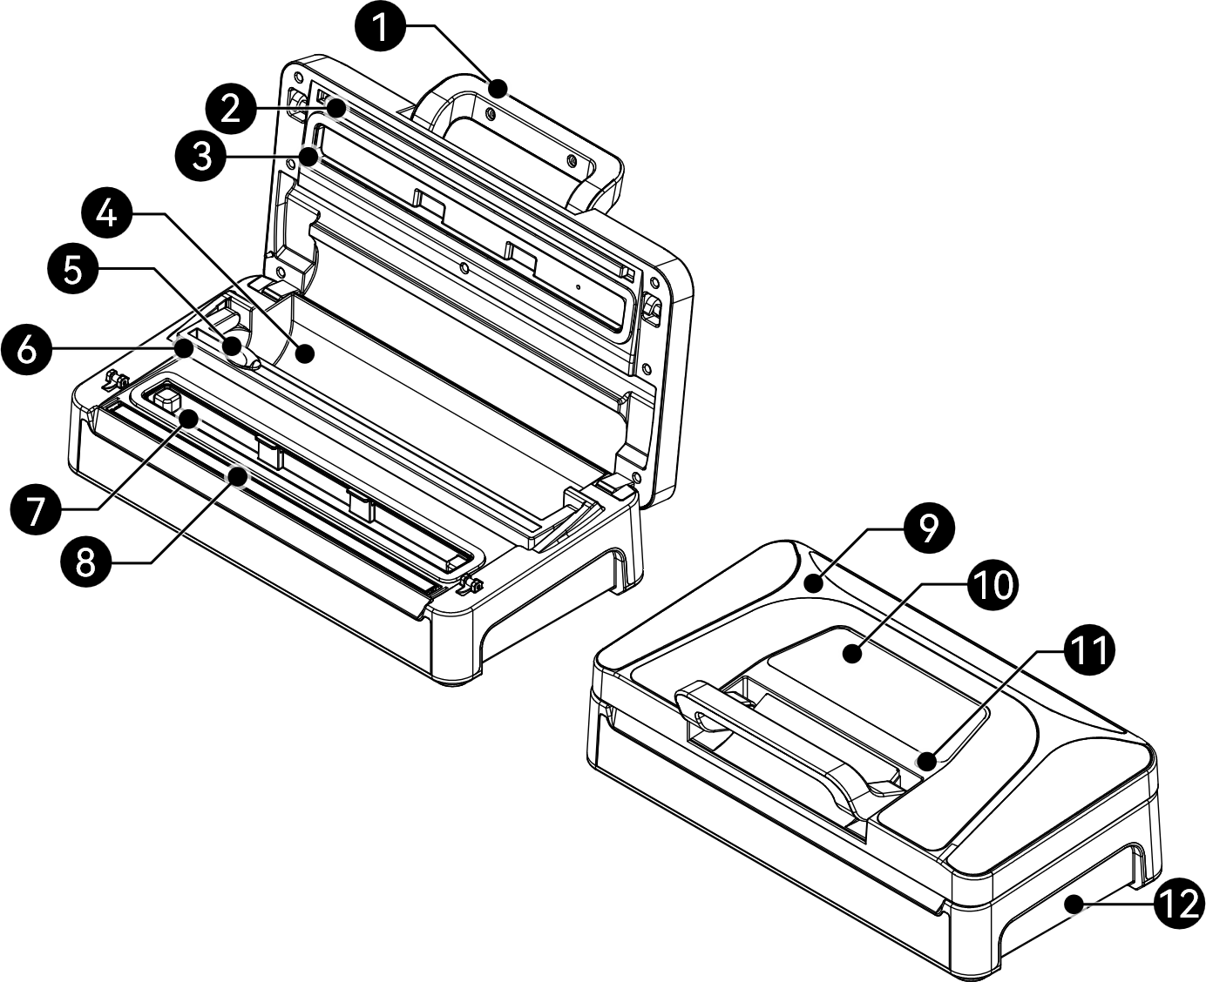
Product Components
Figure 1




1 | Locking handle | 7 | Removable liquid catch tray / chamber
2 | Seal pad | 8 | Seal bar
3 | Sealing gasket | 9 | Lid
4 | Roll compartment | 10 | Control panel
5 | Cutter | 11 | Vacuum port
6 | Cutting guide | 12 | Body

Note：After operation, the seal bar becomes hot. Do not touch it to avoid injury. The cutter contains a sharp blade. Do not handle the underside to avoid injury.

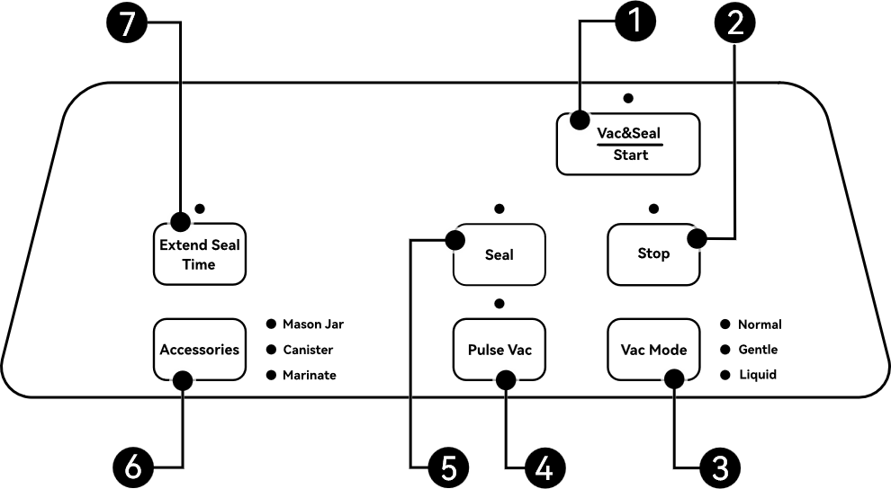
Features and Options

Figure 2

- Vac&Seal / Start button
  - Press this button to start operation based on the mode selected in Vac Mode or Accessories.
- Stop button
  - Press this button at any time during operation to stop the process.
- Vac Mode button
  - Select the appropriate vacuum mode according to the type of food being sealed.
    - Normal Mode: For higher vacuum pressure.
    - Gentle Mode: For delicate items at reduced pressure.
    - Liquid Mode: For liquid or moist foods.
- Pulse Vac button
  - Press and hold this button to manually control the vacuuming process.
  - Once the desired vacuum level is reached, press the Seal button to start sealing.
- Seal button
  - Press this button to start the sealing process immediately.
- Accessories button
  - Select the appropriate mode according to the type of vacuum accessory being used. The machine will remember the last selected mode. Please use the vacuum hose when operating in this mode.
    - Mason Jar：For vacuum sealing Mason jars.
    - Canister：For vacuum containers and zipper bags with a valve.
    - Marinate：For marinating food in vacuum containers.
- Extend Seal Time button
  - Press this button before operation to extend the sealing time for Vac & Seal and Seal functions.

Operation Instructions

How to use the built-in cutter
- Open the lid.
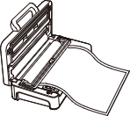
- Lift the cutting guide.
- Pull out the desired length of bag material from the roll.
- Lower the cutting guide back to its original position.
- Slide the cutter firmly across the bag to make a clean cut.
Figure 3
Note: The cutter contains a sharp blade underneath. Use care when raising and lowering the cutter guide to avoid risk of injury.

How to use the Seal function
To make a bag or make a seal only, simply：
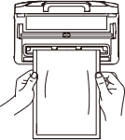
- Place the open end of the bag in the vacuum chamber.
- Close the lid and press down on the handle to lock it.
- Press the “Seal” button. (If the bag opening is wet, press “Extend Seal Time” before sealing.)

Figure 4

How to extend the seal time
- For a longer seal, press the "Extend Seal Time" button prior to initiating a Vacuum & Seal or Seal Only operation.
- The extended time setting will remain active. To revert to the default seal time, press the "Extend Seal Time” button again before starting the next process.
- Once the machine re-enters standby mode or is re-plugged into the power outlet, the seal time will revert to the default setting.
Note：When the Extend Seal Time function is enabled, the intelligent seal time adjustment is temporarily disabled. For continuous operation in this mode, allow at least 20 seconds between cycles and open the lid to allow the machine to cool down.

How to use the Vacuum & Seal function
Vacuum Seal Solid Foods
Before you start, please note that there are two modes for solid foods:
- Normal Mode: For higher vacuum pressure.
- Gentle Mode: For delicate items at reduced pressure.
- Place the open end of the bag in the vacuum chamber.
- Close the lid and press down on the handle to lock it.
- Select the vacuum mode: Normal/Gentle.
- Press the "Vac&Seal / Start" button to start the process. (To cancel, press the Stop button.)
Note：Before vacuum sealing valuable or fragile items using Gentle mode, it is recommended to first test the vacuum level with other items to ensure the compression meets your needs and to avoid insufficient vacuum or damage to the items.

Vacuum Seal Liquids
- Do not overfill the bag, leaving a recommended 7 inches of space between the liquid and the bag opening.
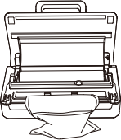
- Keep the bag upright and always ensure the liquid level stays below the level of the sealing strip.
- Place the open end of the bag in the vacuum chamber.
- Close the lid and press down on the handle to lock it.
- Select the vacuum mode: "Liquid".
- Press the "Vac&seal / Start" button to start the process. (To cancel, press the Stop button.)
Figure 5

How to use the Pulse Vac function
Standard Pulse Vac
- Place the open end of the bag in the vacuum chamber.
- Close the lid and press down on the handle.
- Press and hold the "Pulse Vac" button to start the vacuum process.
- Release the "Pulse Vac" button to stop vacuuming.
- Press the "Seal" button to seal the bag.
Alternate Pulse Vac
- Place the open end of the bag in the vacuum chamber.
- Close the lid and press down on the handle.
- Select the vacuum mode: Normal/Gentle.
- Press the "Vac&Seal / Start" button to start the vacuum process.
- Press and hold the "Pulse Vac" button to control the vacuum process.
- Release the "Pulse Vac" button to stop vacuuming.
- Press the "Seal" button to seal the bag.
Note: If no action is taken within 10s after releasing the Pulse Vac button, the machine will exit the Pulse Vac mode and release the vacuum.

How to use the hose
- Adjust the orientation of the round nozzle according to the type of accessory being vacuumed.
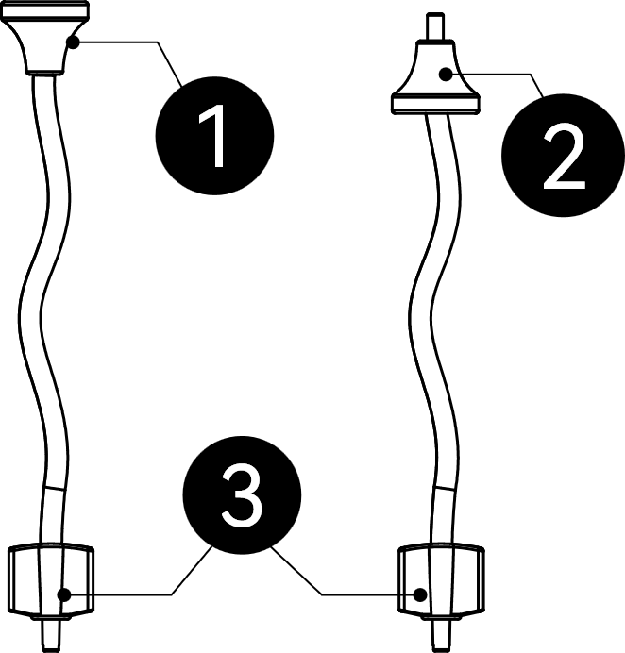
- For Mason Jar adapters and zipper bags with valves, use the round nozzle in Figure 6/① orientation
- For vacuum canisters and bottle stoppers, select the round nozzle orientation according to the size of the vacuum port: Figure 6/① or Figure 6/②.
- The flat nozzle of the vacuum hose (Figure 6/③) is used to connect to the external vacuum port on the machine lid (Figure 1/⑪).
Figure 6
Note：When inserting the flat nozzle (Figure 6/①) into the external vacuum port, pressing down while slightly twisting will make installation easier.

How to vacuum seal Mason Jars
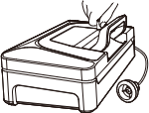
- Put the lid on the Mason jar.
- Attach the adapter to the Mason jar (without the retaining ring.)
- Insert one end of the hose firmly in the machine’s vacuum port.
Figure 7
- Attach the other end of the hose to the Mason jar adapter. (Figure 7)
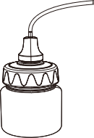
- Close the machine’s lid and press down the handle to lock it.
Figure 8
- Press the “Accessories” button to select the Mason Jar mode.
- Press the “Vac & Seal / Start” button to start the process. (To cancel, press the Stop button.)(Figure 8)

How to vacuum Canisters
Before use, please check that your vacuum canister is compatible with the vacuum hose.
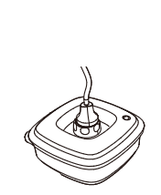
- Turn the canister's valve to "Vacuum".
- Insert one end of the hose firmly in the vacuum port.
- Attach the other end of the hose into the canister's valve.
- Close the machine's lid and press down the handle to lock it.
- Press the "Accessories" button to select the Canister mode. (Figure 9)
Figure 9
- Press the "Vac&seal / Start" button to start the process. (To cancel, press the Stop button.)
- Turn the canister's valve to "Lock" when the process is complete.

How to marinate
Before use, please check that your vacuum canister is compatible with the vacuum hose.
- Put the food in a vacuum canister.
- Turn the canister's valve to "Open".
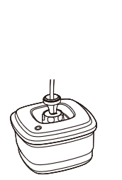
- Insert one end of the hose firmly in the vacuum port. (Figure 7)
- Insert the other end of the hose into the canister's valve. (Figure 10)
- Close the machine's lid and press down the handle to lock it.
- Press the "Accessories" button to select the Marinate mode.
Figure 10
- Press the "Vac&seal / Start" button to start the process. (To cancel, press the Stop button.)
Note:
- Only use vacuum canisters specifically designed for vacuum sealing.
- Hot food should be cooled to room temperature before vacuum sealing in a canister.
- Do not place a canister with the lid closed in a microwave.

Maintenance
- Make sure the machine is placed on a flat, clean, and dry work surface.
- When the machine is not in use, do not engage the locking latches to avoid prolonged compression of the sealing gasket, which may affect performance.
- Clean the sealing gasket, seal pad, seal bar, vacuum chamber, and removable liquid catch tray at least once a week.
- The seal bar and sealing gasket may remain hot after operation. Allow the machine to cool down completely before performing maintenance.
- Disconnect the power supply before cleaning.
- Use a soft-bristle brush to clean the sealing gasket, seal pad, seal bar, vacuum chamber, removable liquid catch tray, and vacuum hose. Do not use hard brushes, as they may damage the machine.
- After use, remove the removable liquid catch tray, clean and dry it thoroughly, and wipe any remaining debris or dust inside the vacuum chamber with a damp cloth or paper towel.
- After each operation, check whether the sealing gasket is deformed and whether the high-temperature tape is damaged or peeling off. Replace them promptly if necessary.
- The removable liquid catch tray and vacuum hose are not suitable for high-temperature cleaning methods, such as dishwashers.

Troubleshooting

Cannot operate
- Ensure the unit is securely plugged into a power outlet.
- Inspect the power cord for damage. If the cord is frayed or damaged, replace it immediately or contact customer support.

Insufficient vacuum
- Make sure the open end of the bag is fully positioned inside the lower sealing gasket.
- Ensure that a textured (embossed) vacuum bag is used.
- Check whether the sealing gasket is damaged, folded, or improperly installed.
- Check the bag for damage, such as punctures or pinholes.
- Make sure there are no food residues or foreign objects on the bag opening that could prevent a proper seal. Clean the bag opening and try again.
- Excessive sealing time may cause overheating, which can affect vacuum performance. Open the lid and allow the machine to cool for a period of time before resuming operation.
- If the problem persists after the above checks, contact a qualified technician for service.

Cannot seal or poor sealing performance
- The open end of the bag is not properly positioned on the seal bar.
- Make sure the sealing area is free of moisture, particles, debris, or dust.
- The seal pad is not installed.
- The default sealing time may be insufficient. Extend the sealing time and try again.
- If the problem persists after the above checks, contact a qualified technician for service.

Bag loses vacuum after sealing
- Check whether the high-temperature tape is damaged or peeling off. Replace it promptly. Otherwise, the seal bar may melt through the bag, causing air leakage.
- Improper sealing temperature may affect the seal:
- Excessive heat may melt the vacuum bag.
- Insufficient heat may result in an incomplete seal. Refer to “Insufficient Vacuum” or “Cannot Seal or Poor Sealing Performance” for solutions.
- Sharp food items may puncture the bag and create pinholes. To prevent this, cover sharp edges with paper towels or use a protective sheet, then reseal with a new vacuum bag.
Note：Some fruits and vegetables may release gases if they are not properly blanched before packaging, or if hot food is sealed. This may cause the bag to loosen and is a normal occurrence, not a leak.

Error alarm
- If the machine emits a continuous beep and the indicator lights flash rapidly after pressing “Vac & Seal / Start” or “Seal”, the lid is not locked. Make sure the lid is fully closed and the handle is pressed down.
- If continuous beeping and rapidly flashing indicator lights occur during vacuuming, the machine cannot reach the target pressure. Check that the handle is locked and the vacuum bag is not damaged. Replace the bag and try again.
- If the issue persists, please contact customer service for assistance.

No vacuum in accessories mode
- Check whether the flat nozzle of the vacuum hose is fully inserted into the external vacuum port. Firmly twist and push the nozzle again to ensure it is completely seated.
- Check whether the handle is fully pressed down. Press the handle to lock the lid, then try again.
- Open the lid and check for any foreign objects on the sealing gasket or in the vacuum chamber (e.g., the roll bag crossing over the vacuum chamber). Remove any obstructions and try again.
Note：If the problem cannot be resolved using the above steps, please contact customer service for further assistance. Do not disassemble the machine yourself.

Liquid intrusion (Special circumstances)
If liquid enters the vacuum chamber:
  - Immediately switch off the power and wait at least 5 minutes to allow the seal bar to cool down.
  - Remove the removable liquid catch tray and wipe away any liquid.
  - Dry the liquid inside the vacuum chamber thoroughly.
  - Place paper towels or a tray under the machine, then reconnect the power.
  - Close the lid, press and hold “Pulse Vac” for 20 seconds, then press “Stop” to release the air. Repeat this process five times to help expel liquid from the internal tubing.
  - Open the lid, place paper towels or a tray under the machine, and leave the machine in a well-ventilated area to air dry for 48 hours. Do not tilt or invert the machine during this period.

If liquid enters the seal bar：
- Do not tilt or invert the machine. Switch off the power and wait 10 minutes to allow the seal bar to cool and the liquid to drain.
- Clean and dry any liquid from the removable liquid catch tray and the vacuum chamber.
- Open the lid, place paper towels under the machine, and leave it in a well-ventilated area to air dry for 24 hours. Do not tilt or invert the machine during this period.
- Place paper towels under the machine and reconnect the power.
- Close the lid, press and hold “Pulse Vac” for 20 seconds, then press “Stop” to release the air. Repeat this process five times to help expel liquid from the internal tubing.
- Open the lid again, place paper towels under the machine, and leave the machine in a well-ventilated area to air dry for 48 hours. Do not tilt or invert the machine during this period.
Note：If the machine is not cleaned regularly, the internal tubing may become clogged, which can affect vacuum performance. In this case, please contact after-sales service to have the tubing replaced.

Technical Specifications
Model Number | V22
Power supply | 110~120Vac 60Hz
Power | 185W
Pump | Dry pump
Pressure | -28.3 inHg
Seal wire width | 0.07 inch ×2
Maximum seal width | 12.4 inch
Dimensions | 15.4×7.9×4.3 inch
Weight | 5.3 lb.

Vacuum Packaging Basics
Vacuum packaging extends the shelf life of food by removing most of the air from sealed containers, preventing fresh air from entering and reducing oxidation. This helps preserve the flavor and overall quality of the food. Additionally, it inhibits the growth of aerobic microorganisms, which can lead to the following issues under certain conditions:
Mold – Mold cannot grow in a low-oxygen environment, so vacuum packaging can effectively eliminate it.
Yeast – Yeast causes fermentation, which can be identified by smell and taste. It requires water, sugar, and moderate temperatures to grow and can survive with or without air. Refrigeration slows yeast growth, while freezing halts it completely.
Bacteria – Bacteria cause unpleasant odors, discoloration, and/or soft or slimy textures. Under the right conditions, Clostridium botulinum (the bacterium that causes botulism) can grow in the absence of air and cannot be detected by smell or taste. While extremely rare, botulism can be very dangerous.
As with any other storage method, it is important to inspect food for spoilage before consuming it.
To preserve food safely, it is crucial to maintain low temperatures. The growth of microorganisms can be significantly slowed at temperatures of 39ºF (4ºC) or below. For long-term storage, always freeze perishable foods that have been vacuum packaged. It is important to note that vacuum packaging cannot reverse food deterioration; it only slows changes in quality. The length of time food will retain its optimal flavor, appearance, and texture depends on the age and condition of the food when it was vacuum packaged.
Note: Vacuum packaging is not a substitute for refrigeration or freezing. Any perishable foods that require refrigeration must still be refrigerated or frozen after vacuum packaging.

Storage Guidelines
Vegetables should be blanched before vacuum sealing. Blanching stops enzyme activity. After blanching, immerse the vegetables in cold water. Before vacuum sealing, thoroughly dry the vegetables with kitchen paper.
Cruciferous vegetables (such as broccoli, Brussels sprouts, cabbage, cauliflower, kale, and radish) naturally release gases during storage. Therefore, after vacuum sealing, it is recommended to store them in the refrigerator.

Not all foods are suitable for vacuum sealing!
Do not vacuum seal garlic, mushrooms, or other fungi.
In a low-oxygen environment, these foods may promote the growth of harmful microorganisms and may pose serious health risks if consumed.

Vacuum food storage reference
Storage | Foods | Typical  Storage | Vacuum  Packaging
Frozen | Meat | 6 months | 15-20 months
 | Fish, Seafood | 6 months | 10-12 months
 | Dried fruit,  Coffee beans | 6-9 months | 18-24 months
Refrigerated | Meat | 2-3 days | 12-13 days
 | Fish, Seafood | 2-3 days | 6-8 days
 | Cooked meat | 2-3 days | 10-14 days
 | Eggs | 2-3 days | 30-50 days
 | Vegetables | 2-3 days | 7-10 days
Dry | Bread | 1-2 days | 6-8 days
 | Cookies | 4-6 months | 12 months
 | Noodles | 5-6 months | 12 months
 | Rice | 5-6 months | 12 months
 | Flour | 4-5 months | 12 months
 | Crackers | 3-4 months | 12 months
 | Coffee | 2-3 months | 12 months
 | Tea | 5-6 months | 12 months
 | Powdered Milk | 1-2 months | 12 months

Thank you for purchasing the Model V22 Suction Vacuum Sealer.
Enjoy using your new machine!

